**PROJECT TITLE**

**Gait-Based Health Risk Detection Project**

**BACHELOR OF TECHNOLOGY**

**In**

**DEPARTMENT OF COMPUTER SCIENCE ENGINNERING**

**By**

P.Likitha 2420030028

G.karthika 2420030076

A.Sindhuja 2420030094

Under the Esteemed Guidance of

**Venkateswara Rao sir**





**K L (Deemed to be) University**

**DEPARTMENT OF COMPUTER SCIENCE ENGINEERING**



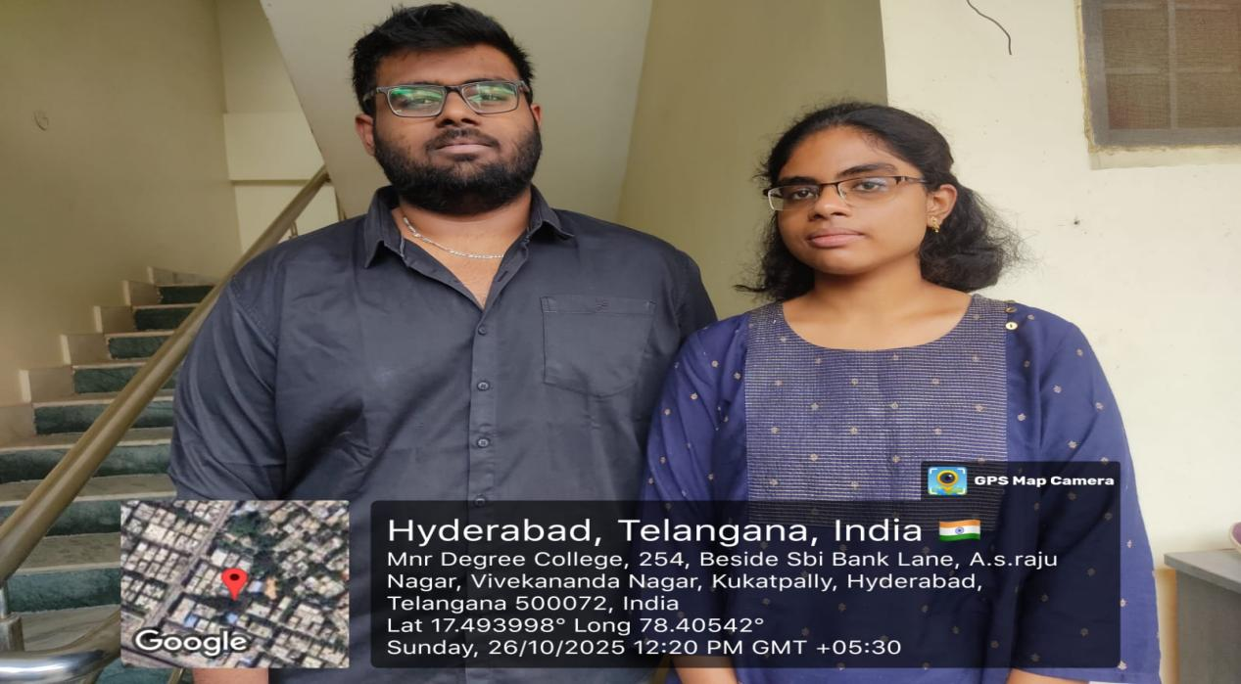

Interview Questions with the clients-Dr.Chandrashekar,Dr.Ramesh,Dr.Priya,Dr.Keerthi.

1.What are the main health risks the system should be able to detect?

2.What target population is this system intended for (elderly, Parkinson’s patients, general public)?

3.What are the clinical or business goals driving this project?

4.What is the expected accuracy or sensitivity for risk detection?

5.What key performance indicators (KPIs) should define project success?

6.How much historical or baseline data is available for model training?

7.How will data privacy and consent be managed?

8.How will we handle multi-source data synchronization?

9.Why is continuous monitoring important for your users?

10.Why do you believe AI can enhance risk prediction accuracy?

11.Why does the project prioritize specific diseases or conditions?

12.What enhancements are envisioned after initial deployment?

13.What other health metrics could be combined with gait data?

14.How can the system evolve for preventive care rather than detection only?

15.How might wearable technology trends influence your expectations?

16.How should we design for long-term scalability?

17.What models are being considered (CNN, LSTM, Transformer, Hybrid)?

18.What features are most predictive of fall or disease risk?

19.What metrics (AUC, F1, sensitivity) will guide optimization?

20.Why must patient data be anonymized before analysis?

21.Why is it critical to track model drift over time?

22.Why should the system support auditability of predictions?

23.Why is transparency important for regulatory acceptance?

24.Why might clinicians resist fully automated risk predictions?

25.What validation datasets will be used?

26.What cross-validation techniques will be applied?

27.How will clinical ground truth labels be generated?

28.How will model robustness be measured?

29.How can false alarms be minimized in deployment?

30.Why did you choose our team for this collaboration?

31.Why is this project strategically important for your organization?

32.Why might the healthcare market be ready for this technology now?

33.Why do you want proprietary algorithms rather than open-source ones?

34.Why do you think users will trust and adopt gait-based assessments?

35.How will the system integrate with hospital EMRs or EHRs?

36.How will third-party wearable devices be connected?

37.How will user authentication and authorization be managed?

38.How can cloud-based inference interact with local data capture?

39.How can data be synchronized in real-time?

40.What is the conclusion of this?



